NID

Abstract— Detecting intrusions is essential for protecting contemporary networks, especially in IoT settings and densely populated systems. This project explores the application of Graph Neural Networks (GNNs) for classifying network intrusions by utilizing flow-level data from the ACI-IoT-2023 and CIC-IDS2017 datasets. The goal is to establish a strong system for identifying and categorizing network attacks using graph-based models of network traffic. The project consists of three stages. During the data preparation stage, datasets undergo analysis and preprocessing by means of feature selection, normalization, and addressing class imbalances. Graph representations are created with nodes and edges that illustrate flow-level, session-based, or host-based relationships, enhanced with significant traffic characteristics. Using tools like PyTorch Geometric, the model development stage makes use of GNN designs like as Graph Convolutional Networks (GCNs), Graph Attention Networks (GATs), and GraphSAGE, among others. To maximize hyperparameters, models are evaluated after being trained with cross-entropy loss. Metrics including accuracy, precision, recall, and F1-score are used to evaluate the models using reserved data during the evaluation phase. The results highlight how well GNNs can depict complex relationships in network traffic, offering important new information on graph representation and intrusion detection architecture.
Keywords— Intrusion Detection, Network Security, Graph Neural Networks, Graph Representation, Network Traffic Analysis
- INTRODUCTION
As connected devices rapidly proliferate and network environments grow more complex, intrusion detection has emerged as an essential component of network security. Conventional approaches for identifying harmful activities frequently have difficulty managing the complex connections found in network traffic, especially in busy networks and IoT environments. These obstacles require sophisticated methods capable of modelling and examining intricate network interactions while ensuring both scalability and precision. Graph Neural Networks (GNNs) have become a strong method for understanding connections in graph-structured data, rendering them very effective for network intrusion detection. Utilizing GNNs allows for the representation of network traffic in graph form, with nodes and edges encoding significant relationships like flows, sessions, or communications between hosts. This graph-oriented method offers a more profound insight into the fundamental network dynamics and enhances the accuracy of classifying different types of intrusions. This project investigates the use of GNNs for detecting network intrusions through two important datasets: ACI-IoT-2023, designed specifically for IoT security, and CIC-IDS2017, a commonly referenced standard for intrusion detection. The objective is to create graph representations of network traffic, deploy advanced GNN architectures, and assess their effectiveness in identifying network attacks. The rest of this report details the methodology, which encompasses data preprocessing, graph construction, model development, and evaluation. Findings from this study highlight the promise of GNNs in enhancing network security, establishing a basis for future investigations in real-time intrusion detection and extensive network analysis.
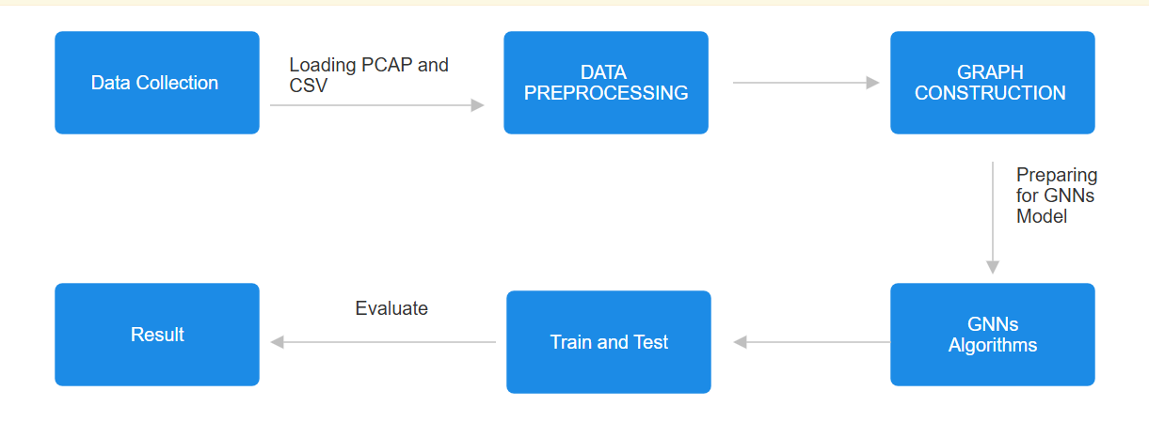
Fig:1 Flow chart

Related work

This section talks about the other previous works on prediction of NID(Network Intrusion System)with the aid of a Deep learning algorithm and Machine learning algotithms,[1] The paper utilize a Hierarchical Adversarial Attack(HAA) method using a shadow graph neural netwrok (GNN) model and random walk with Restart(RWR) for node selection.The methodology involves generating adversarial examples by identifying crtical features with mapping and minimally perturbing them. Limitations include dependency on limited and imbalanced attack data which affects generalization. The model reduces classification precision by over 30% on GCN and Jk-Net.Future scope includes optimizing adversial startegies and testing in diverse IoT scenarios. [2] The paper employs graph neural netwrok (GNNs) for intrusion detection using various models including GCN, GIN and GAT. The methodology involves represenation network dara as graphs, learning embedding from nodes and edges and classifying malicious entities.Limitations include scalability issues with large graph over smoothing in deep netwroks and class imbalance. Accuracy varies across datasets but generally outperforms traditional ML models.Future scope inclues enchaning model scalability, robustness against adversarial attacks and exploring self-supervised learning for better generalization.[3] The paper proposes the SWM-IDS models using Graph neural networks (GNN) and binary whale optimizer(BWO) for intrusion detection in smart waste management system. The methododlogy involves data preprocessing ,feature selection with BWO and classification using GraphSAGE. Limitations include scalbility challenges and limited generalization to real-world scenrios. The algorithms used are GraphSAGE and BWO. The model achienves 99.72% accuracy on CIC-IDS-2018 dataset and 99.68% on the CIC-DDos-2019 dataset. Fututre scope includes real time anomaly detection ,adative learning and federated learning for enchaced secuity.[4] The paper proposes the MEGR-APT system using graph neural networks (GNN) and RDF- based provenance graphs for APT detection. The methodology involves memory effivientsubgraph extraction ,attack represenattion learning with RGCN and graph matching using NTN.Limiattions include challenges in detecting minimal -trace lateral movements and the need for domain knowledge in query constrution. The algorithms used are relational graph convolutional netwroks (RGCN) and neural Tensor netwroks (NTN).The models achieves an F1-score of over 95% while siginificantly reducing memmory consumpotion.Future scope includes automating 1uery graph constrution, enchaning streaming capabilities and integrating network traffic analysis.[5] The study uses CopulaGAN for data augumentation to handle class imbalance and Random forest for deature selection and classification,selecting the top 35 features.The model achieves accuracy and F1-score above 99% outperforming XGBoost ,lightsGBM,SVM and KNN.The Kolmogorov-smirnov (KS) test validates synthetic data quality.Limitations include reliance on the CIC-IDS-2017 dataset and untested performance on hihly imblanced real-world data.Future work involves detecting zero-day attacks,integrating explainable AI for better interpretability and testing on real hospital network.[6] The paper uses GraphSAGE with MPNN and MLP layers to leverage edge feature for multi-class intrusion detection. It achieved 96.68% training and 93.32% testing accuracy on the CIC-IDS-2017 dataset. However, it has longer testing time due to the additional MLP layers and its only tested on CIC-IDS-2017.Futurework includes enchaining model efficiency ,exploring complex network structures and validating on other dataset.[7]The Paper uses a GCN-based GNN model with AEN graph constructs for network anomaly detection . It achieved 76% accuracy on the DDoS dataset and 88% accuracy on the TOR-non TOR dataset. Limitation includes lower accuracy on the DDoS data and testing only on two datasets. Future work involves comparing with benchmark models and testing on more datasets. [8] The Paper uses E-GraphSAGE with edge-based analysis for anomaly detection in network traffic. It achieved 92.35% accuracy on the BETH dataset and 85.48% accuracy on the MedBIOT dataset. Limitations includes lower performance on MedBIoT and reliance on overbalancing for unbalancing data. Future work involves optimizing subgraph generation , exploring better preprocessing methods, and enhancing memory efficiency. [9] The Paper uses Graph Neural Network(GNN) for network intrusion detection achieving 91% accuracy, outperforming models like Logistic Regression, Random forest and SVM. It uses the KDDCUP99 dataset and compare various ML models, including decision Tress and Naïve Bayes. Limitation include dependency on an outdated dataset (KDDCUP’99) and challenges with data preprocessing and class imbalance. Future work aims to improve the GUI, optimize feature selection and deploy the model globally for broader network security application. [10] The paper uses Graph Attention Networks(GAT) for real time intrusion detection on CAN bus networks, achieving 99.75% accuracy for DOS, 99.50% for fuzzy and 100% for spoofing attacks. It transform CAN message into graphs and optimizes detection time with a graph size of 100 nodes. Limitations include the models dependency on specific graph size and potential challenges in detecting complex attack pattern. Future work involves enhancing real time implementation and extending the models applicability beyond auto motive systems. [11] The paper uses GraphSAGE combined with Ensemble learning for network intrusion detection, achieving 96% precision 94% recall and F1-score of 0.95 on the CIC-IDS-2017 dataset. It addresses class imbalance using SMOTE and K-means clustering. Limitations include reliance on specific threshold values for adjacency matrix reconstruction and potential overfitting due to minority class oversampling. Future work involves exploring other GNN models and enhancing adjacency matrix construction for better performance.[12] This Paper used Channel-centric Spatic-Temporal Graph Networks (CCSTGN) for network intrusion detection, achieving 99.88% AUC 95.06% F1-score on the NF-UNSW-NB15-v2 dataset. It combines graph and temporal representations for dynamic learning. Limitations include high computational complexity and dependency on effective data preprocessing. Future work involves exploring graph attention networks and enhancing data preprocessing for better model performance.[13] This Studied uses a GNN-BiLSTM model for intrusion detection in IoMT systems, achieving 99.98% accuracy,99.98% precision and 99.97% F1-score on the IoT-Healthcare security dataset. It combines Graph Neural Networks for spatial data processing with Bi-LSTM for temporal pattern recognition. Limitation include dependency on binary classification and challenges in detecting insider attacks. Future work involves expanding detection to ransomware and DDos attacks and enhancing insider threat detection.[14] This paper uses a GNN-based anomaly detection algorithm to identify attack paths by transforming NIDS logs into a network graph. It applies to a two-stage unsupervised model to detect and prioritize threats. Limitations include challenges in detecting advanced attacks and variations in normal traffic patterns. The method employs a modified InfoGraph model with outlier detection techniques like COPOD,LOF and HBOS. The best model (COPOD) achieved 89.28% accuracy with an AUC score of 0.72. Future work aims to refine detection methods, test on diverse datasets and improve adaptability to dynamic attacks.[15] The paper proposes E-T-GraphSAGE, a hybrid Network Intrusion Detection System (NIDS) combining Graph Neural Networks (GNNs) and Transformers. It captures complex relationships in network data using GraphSAGE and enhances detection accuracy with self-attention mechanisms. The main limitation is difficulty in distinguishing similar attack types such as DDOS and DOS, due to feature overlap. The model employs GraphSAGE for local feature aggregation and Transformer layer for global dependency capture. It achieves high accuracy, with an F1-score of 1.00 on BOT-IoT and 0.67 on NF-ToN-IoT. Future work aims to develop unsupervised models and optimize the system for edge computing devices. [16] The paper uses a 2-dstage Graph-Level anomaly detection (GLAD) model with modified InfoGraph for attack path detection, achieving an AUC of 0.72 and F1-score of 0.55 on the UNSW-NB15 dataset. It leverages Graph Neural Networks (GNN) and unsupervised outlier detectors like COPOD. Limitations include dependency on outlier detectors and challenges with diverse benign traffic patterns. Future work involves testing on more datasets and improving detection of advanced attacks.[17] The paper uses E-Transformer-GraphSAGE(ETG), combining Graph Neural Network and Transformers for network intrusion detection, achieving 99.99% accuracy on BOT-IoT,94.52% on NF-BoT-IoT and 99.93% on NF-ToN-IoT. It leverages edge embeddings abd self-attention for enhanced detection. Limitations include difficulty distinguishing DDos from Dos attacks and high computational costs. Future work involves unsupervised learning and optimizing ETG for edge network servers.[18] The study tell uses Graph Convolutional Network(GCN) for hardware Trojan detection at the Register transfer level(RTL), achieving 97% accuracy and 100% recall. It employs Data Flow Graphs (DFG) and multi-Layer perception (MLP) for classification. Limitations include dependency on DFG generation and challenges with complex circuit design. Future work involves optimizing real-world hardware and improving scalability and efficiency. [19] The study uses Graph Neural Network (GNN) and Transformer models (BERT,T5,RoBERTa) to detect anomalies in cybersecurity events from the BETH dataset. GraphSAGE, GCN and GIN encode event relationship, while Transformers and Variational Autoencoders (VAEs) process complex features. Isolation Forst is used for final anomaly detection ,achieving an AUROC of 0.932 an 8% improvement over the baseline. Limitations include high computational cost, reliance on unlabeled data and limited generalization. Future work focuses on scalability, real world testing and explainability of detected anomalies.[20] The study proposes an adaptive-wavelet CNN for DDoS attack detection, using a Genetic Neural Network (GNN) to generate adaptive wavelets for feature extraction. A Convolutional Neural Network (CNN) then classifies internet traffic as normal or anomalous. Limitations include the need for tagged data, high computational cost, and potential challenges with evolving attack patterns. Algorithms used include GNN, DWT, CNN and a Multi Objective Genetic Algorithm. The model achieved 95% accuracy, improving detection rates by 7%. Future work focuses on unsupervised learning, real-time adaptability and testing on broader datasets. The paper present a GNN-based few-shot learning model for credit car fraud detection using limited data. It constructs a learnable parametric adjacency matrix and applies a graph convolutional network (GCN) for feature extraction. Limitations include challenges with imbalanced labels, graph construction and generalization to diverse fraud patterns. Algorithms used are GNN, GCN, Logistic Regression, SVM, XGBoost and GraphSAGE. The model outperformed traditional classifiers achieving higher stability and accuracy in few shot settings. Future work focuses on semi-supervised learning, improving robustness and broader fraud detection applications. Additionally, graph neural network (GNN) based regression model with graph convolution network (GCN) as the primary algorithm achieving an accuracy of 99.56% r2 score. The methodology involves converting three -phase invert circuits into graph representations using bond graph modelling following by dataset generation and feature extraction. Limitations include dependency on dataset range and operating conditions which may affect generalization. The future scope includes optimizing power converter design s and exploring broader circuit configurations for enhanced prediction capabilities.

- MATERIALS AND METHODS
- Data Collection :
ACI-IoT-2023 and CIC-IDS2017 are the datasets used in this study, and they came from publically accessible repositories. These datasets include thorough flow-level information appropriate for studies on intrusion detection. While CIC-IDS2017 includes a broad range of attack scenarios across several network protocols, the ACI-IoT-2023 dataset concentrates on network incursions unique to the Internet of Things. When combined, these datasets provide a varied depiction of network traffic in both attack and regular scenarios. Along with regular traffic, the data contains other types of network intrusions, including port scanning, DoS, DDoS, and other malevolent actions. The datasets properties capture crucial traffic statistics, and each entry represents a network flow or session. To ensure a fair proportion of normal and attack occurrences across the splits, the datasets were separated into training, validation, and testing subsets for this study.

- Model Configuration:
Choose the architecture and configuration for the GCN, GAT, GraphSAGE, GIN, and MPNN models of Graph Neural Networks (GNNs) that will be utilized in this investigation. Specify the architecture of each model, including the number of GNN layers, the final classification layer, hidden dimensions, and activation functions. Additionally configurable are hyperparameters like learning rate, batch size, and optimizer (like Adam).

- Dataset Preparation:
Verify that the ACI-IoT-2023 and CIC-IDS2017 datasets meet the standards for graph-based models. This includes Preprocessing: Transforming flow-level information into graph formats by choosing the suitable representation (e.g., session-oriented, flow-oriented, or host-oriented graphs). Annotation: Configuring node attributes (e.g., traffic data such as duration and bytes per second) and edge attributes (e.g., communication rates or time intervals). Structuring: Arranging the processed information into a format suitable for GNN frameworks like PyTorch Geometric or DGL. This involves generating adjacent matrices, edge lists, and feature matrices for the subsets used in training, validation, and testing. This phase guarantees that the datasets are entirely ready for integration with the selected GNN models and training processes.

- Analyze the results:
Analyze the evaluation outcomes to identify areas needing enhancement and to understand the model's strengths and weaknesses.

- Refine the model:
To improve the model's performance, additional training on specific datasets or tasks is necessary. Various optimization strategies, regularization techniques, and hyperparameter modifications can all be employed to accomplish this.

- PROPOSED METHODOLOGY

This Research uses flow -level data from the ACI-IOT-2023 and CIC-IDS-2017 datasets to use Graph Neural Network (GNN) in a systematic manner for classifying network intrusion. Preprocessing, training, evaluation, graph creation and data collecting are some of the sequential phases that make up the technique. Five cutting-edge GNN architectures like GCN, GAT, GraphSAGE, GIN and MPNN. This Methods are used to assess how well graph-based intrusion detection works.

1. Data Collection
Obtaining the ACI-IoT-2023 and CIC-IDS-2017 databases is the first step. Network traffic classified with different attack kinds can be found in these databases. While CIC-IDS2017 offers through assault scenarios across numerous network protocols, ACI-IoT-2023 concentrates on intrusion unique to the Internet of Things. To comprehend the structure and characteristics of these datasets, the documentation that goes with them is examined.

2. Data Preprocessing:
Preprocessing ensures the datasets are clean, structured and ready for analysis. Feature Selection/ Engineering: Relevant features are identified based on their importance for intrusion detection. New features may be created (eg, feature combination or ratios) to enhance model performance. Handling Missing Values: Missing data is addressed using imputation or removal techniques. Normalization: Numerical features are scaled using techniques like standardization or min- mac scaling.
Class Imbalance: Technique such as SMOTE, oversampling or under sampling are used to handle class imbalance, particularly for underrepresented attack classes. The dataset consists of two types of data: PCAP files and CSV files. Initially, we process the PCAP files using PyShark for file capturing, extracting relevant information, and consolidating it into a single DataFrame. Next, we load the CSV files, comprising eight files from the CIC-IDS-2017 dataset and two files from the ACI-IoT-2023 dataset. Using the DataFrame concat method, all the data from the PCAP and CSV files are merged into a unified DataFrame.
In the preprocessing stage, several key tasks are performed to ensure the dataset is clean and ready for analysis:

- Data Loading: The dataset is loaded into a pandas Data frame for further processing.
- Handling Missing Values: Any missing or NaN values in the dataset are identified and appropriately handled, either by removing incomplete rows or imputing missing values.
- Feature Selection: Relevant features are selected from the dataset based on their significance in traffic classification. Unnecessary or redundant features are dropped.
- Label Encoding: Categorical labels in the dataset are converted into numerical representation to facilitate machine learning model training.
- Feature Scaling: Numerical features are standardized or normalized to ensure uniform data distribution, improving model performance.
- Handling Imbalanced Data: The dataset is balanced using under sampling techniques such as SMOTE (Synthetic Minority Over Sampling Techniques) to ensure equal representation of different classes.
- Dimensionality Reduction: Principal component Analysis (PCA) or TNSE art used to reduce feature dimensionality while retaining important information.
- Cluster Construction: A feature-based graph is created using the K-Nearest Neighbors (KNN) approach, where edges are formed between instances with similar features.
- Edge List Generation: The Graph edges list is constructed, connecting each data point to its nearest based on feature similarity.
- Graph Data Transformation: The dataset is transformed into a graph- based format, where each sample represents a node, and edges connect nodes based on computed feature similarity.
- Splitting Dataset: The preprocessed dataset is split into training, validation and testing sets evaluate model performance effectively.
- Converting to PyTorch Format: the structured dataset is converted into pytorch tensors for compatibility with deep learning models such as graph Neural Networks (GNNs).
- Final Data verification: The Transformed dataset is inspected to ensure correctness in terms of node features, edges connections and class distributions.
- Saving Preprocessed Data: The Final processed dataset is saved for efficient reuse in the training and evaluation phases and evaluation phases of model.

Splitting the data: The dataset is split into training, validation and test sets while maintaining class distribution.

3. Graph Construction:
Graph Construction transforms the preprocessed data into a graph representation suitable for GNNs. Three Graph representations are explored:
Host-Based Graph:
Nodes represent hosts (IP addresses), and edges connect frequently communicating hosts. Node features include aggregated statistics like the number of unique Ips contacted or total traffic volume.
Session-Based Graph:
Nodes represent network sessions (flows between a source and destination within a time window) and edges connect sessions that are temporally close or share common attributes. Features are derived from session level statistics like duration and packet counts.

Flow-Based Graph:
Nodes represent individual network flows (packet sharing a 5-tuple: source IP, destination IP, source port, destination port and protocol) and edges connect flows sharing temporal or logical relationships.
Node and edges features are encoded as feature matrices and adjacency matrices to describe the graph topology.

4. Preparing the Data for the Algorithm:
The graph representations are formatted for GNN libraries such as PyTorch Geometric. The data is divided into training, validation and testing, ensuring all graph properties and features are preserved.

5. GNN Concepts and Algorithms:
Graph Neural Networks (GNNs):
GNN are deep learning models designed for graph-structed data. Unlike traditional neural networks, which process feature vector or images, GNN aggregate information from node neighbors using message passing techniques. This enables GNN to capture complex relational patterns inherent in graphs.

6. Training and Testing
The GNN models are trained on the constructed graph using cross entropy loss. Durning training, the model parameters are optimized using Adam optimizers. Validation data is used to tune hyperparameters such as learning rate, number of layers, and hidden dimensions. Early stopping is employed to prevent overfitting.
The test data evaluated the final trained model performance, ensuring robust generalization across unseen network traffic scenarios.

7. Evaluation and Results:
The models are evaluated using metrices that are crucial for intrusion detection, Accuracy, Precision, recall and F1_score.

- OBJECTIVES

To provide a reliable and efficient model for detecting and classifying network intrusions, enabling cybersecurity professionals to better manage and mitigate potential threats in IoT and traditional network environments. To fully examine the ACI-Iot-2023 and CIC-IDS 2017 dataset, identify patterns and trends in network traffic and distinguish between normal and malicious activities. To Create visualization of attack distribution and network activity to aid in quickly understanding and interpreting network anomalies.
To improve intrusion detection strategies, consider the impact of various factor, such as traffic flow patterns, protocol usage and attack severity on network security. Recommend the best graph representations and preprocessing techniques based on traffic characteristics and attack profiles to enhance detection intrusions, enabling proactive threat prevention and mitigation strategies. To aim advance network security frameworks by integrating Graph Neural Network(GNN) models to address the complexity and evolving nature of cyberattacks.

- IMPLEMENTATION

- ABOUT THE DATASET:
The Data is hand collected from various websites with each, and every label verified and sourced Kaggle.
- PREPROCESSING
We don’t have to do a lot of preparation when using an image dataset. We may state that data augmentation is one of the preprocessing methods for improving our accuracy. Preprocessing ensures the datasets are clean, structured and ready for analysis. Feature Selection/ Engineering: Relevant features are identified based on their importance for intrusion detection. New features may be created (eg, feature combination or ratios) to enhance model performance. Handling Missing Values: Missing data is addressed using imputation or removal techniques. Normalization: Numerical features are scaled using techniques like standardization or min- mac scaling.

- MODELS
Graph Convolutional Network (GCN):
GCNs extend traditional convolutions to graphs. They aggregate feature information from a node immediate neighbor and pass it through a learnable transformation are effective for semi-supervised tasks, such as classifying nodes or graphs.
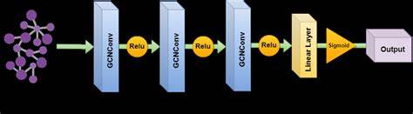

Graphs Attention Networks (GAT):
GAT improves upon GCN by applying attention mechanism. Instead of treating all neighbors equally, GAT assign attention weights to neighbors based on their importance, allowing the model to focus on the most relevant nodes during aggregation.
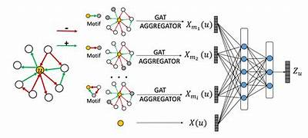

GraphSAGE:
GraphSAGE is designed for large-scale graphs. It generates embedding by samplings and aggregating features from a fixed number of nodes neighbors. This inductive approach allows GraphSAGE to generalize unseen nodes or graphs during training.
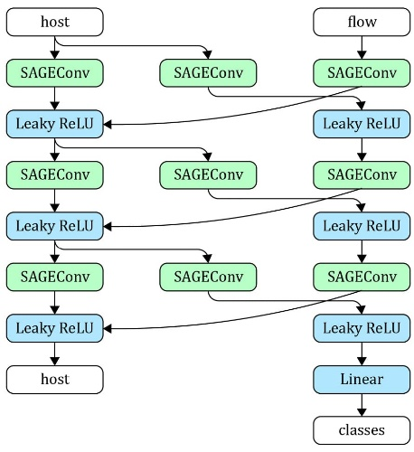

Graph Isomorphism Network (GIN):
GIN are highly expressive GNNs that are specifically designed to capture graph structures. They Utilize a learnable aggregation function that makes them theoretically as powerful as the weisfeiler-Lehman graph isomorphism test, allowing GINs to distinguish between structurally different graphs.
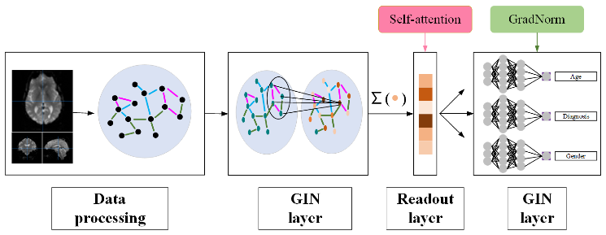

Message Passing Neural Network (MPNN):
MPNNs generalize the, message -passing framework, where nodes exchange information with their neighbors through messages. The aggregated messages and node features are updated iteratively, enabling MPNN to learn rich graphs representations.
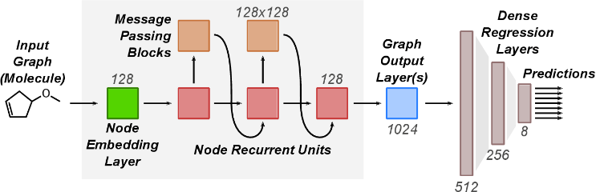

- EVALUATION
Evaluation is an essential phase in any deep learning project since it illustrates where the model is doing well and where it needs to be improved. Deep learning often uses a variety of assessment criteria, depending on the job and type of model being assessed. To detect the attack using deep learning, this process involves evaluating how well the model predicts the Attacks. Methods such as accuracy are chosen as evaluation measures based on specific objectives and study design. These metrics provide quantitative insights into how effectively the model generalizes to new data, which helps to enhance the model for more accurate predictions.
- Accuracy:
In deep learning, accurate metrics evaluate a model's performance by gauging how well it can generate predictions based on the provided dataset. Accuracy, precision, recall, and F1 score are examples of common accuracy measures. These are calculated using true positive, false positive, true negative, and false negative predictions. These metrics aid in assessing the model's performance across a range of tasks, including segmentation, object identification, and classification. They also reveal the model's advantages and disadvantages when it comes to managing distinct classes or categories within the dataset

- Result and Discussion:
Preforming 5 algorithms with their library
TensorFlow: TensorFlow is an open-source AI structure created by Google that gives an entire climate to create and utilize AI models. It offers undeniable level APIs for building brain organizations, overseeing information, and sending models on various kinds of equipment, like computer chips, GPUs, and TPU.
Keras: By abstracting away intricacy, Keras empowers clients to put less accentuation on minute execution subtleties and more on model design and trial and error. It upholds convolutional and intermittent brain organizations, multi-input and multi-yield models, from there, the sky is the limit, making it fit for dealing with an extensive. variety of profound learning errands.
SciKit:
SciKit-learn is a popular open-source python library for machine learning, built on top of numpy, Scipy and matplotlib. It provides simple and efficient tools for data mining and analysis and is widely used for academic research and industry applications.
PyTorch:
PyTorch is an open-source deep learning framework developed by Facebook AI Research Lab. It is widely used for building and training neural networks due to its flexibility, dynamic computation graph and ease of use. PyTorch supports a broad range of tasks in deep learning, including computer vision, natural language processing (NLP) and reinforming learning
This wide range of algorithms highlights the continuous research and development in the field of computer vision.

GCN:
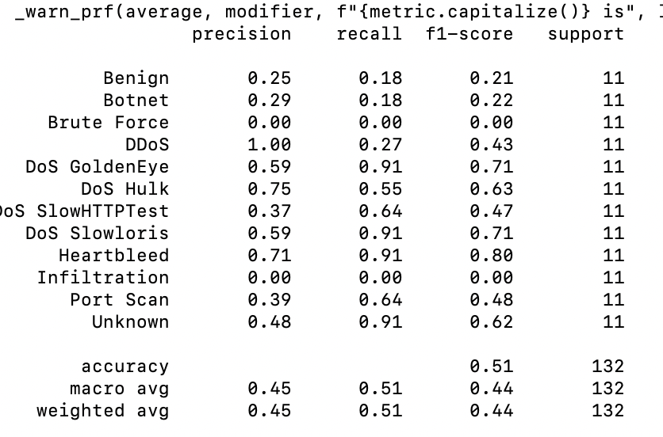

GCN performs moderately well, with decent performance on specific attack types but struggles with certain classes, performance on specific attack types but struggles with certain classes, showing a class imbalance or difficulty learning specific patterns. The Accuracy 51% , F1_score 44%.
Best classes : "DoS GoldenEye" and "DOS Slowloris" show good performance with F1-scores of 0.71.
Weakness: Classes like “Brute Force”, "Infiltration," and several others have zero recall and F1-scores.

GAT:
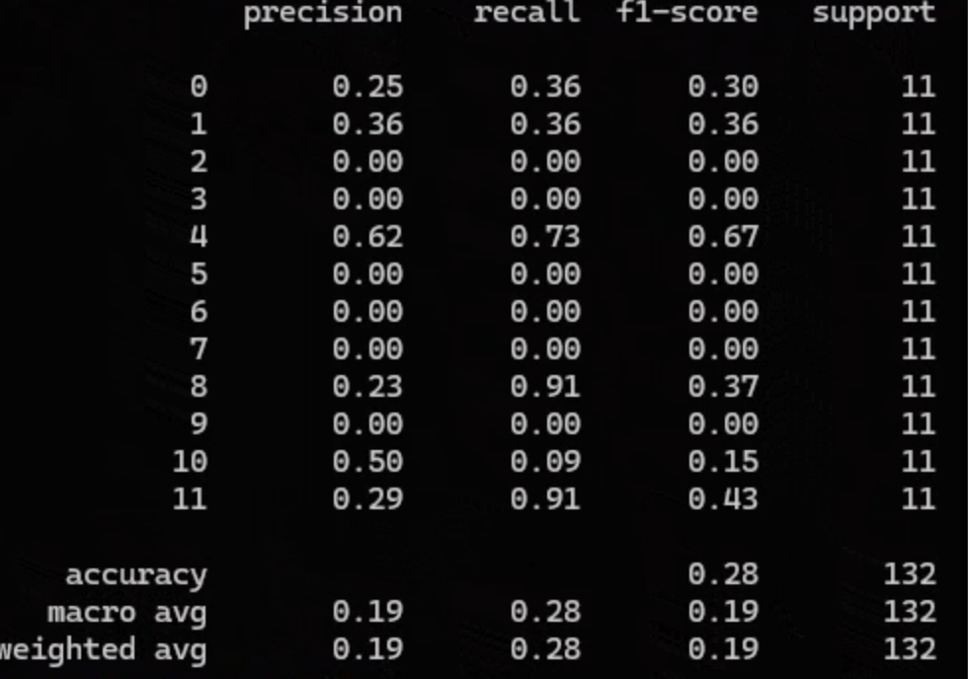
GAT underperforming significantly, with the model struggling to distinguish most classes. The low overall accuracy and weighted average suggest difficulty in capturing meaningful relationships in the data.
Best classes: Class 8 Heartbleed shows high recall.
Weaknesses: Many classes have zero precision, recall and f1-score indicating poor generalization.

GraphSage:
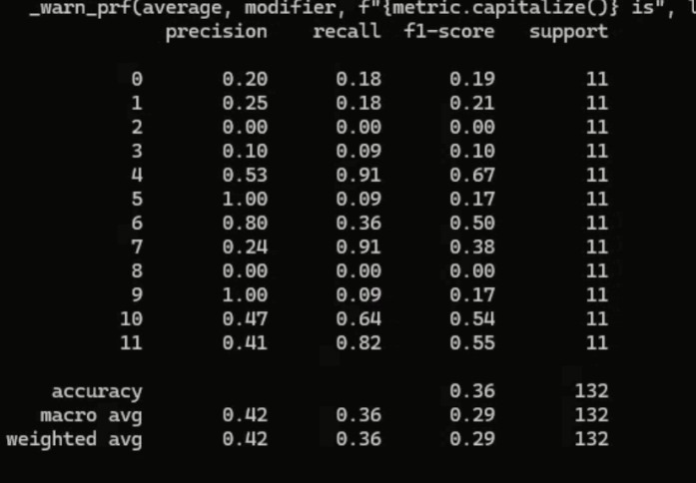

Accuracy 36% GraphSage provides a balanced performance showing improvement over GAT, but not as consistent as GCN. The Model learns better for specific but still fails on others.
Best classes: DoS GoldenEye" (0.67 F1-score) and "Heartbleed" (0.80 F1-score) show strong performance.
Weaknesses: Many classes still have zero F1-scores, but there is a noticeable improvement in certain attack categories.

GIN(Graph Isomorphism Network):
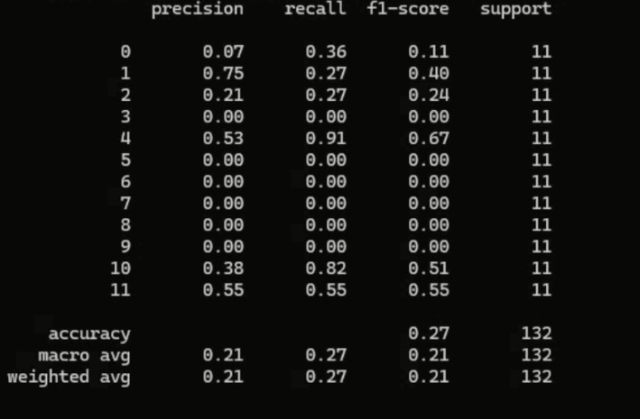
GIN has one of the lowest performance among the models with significant challenges in classification. The model likely overfits or underfits the data causing poor generalization. Accuracy 27%,
Best classes: Class 4 ("DoS GoldenEye") and Class 10 (with 0.51 F1-score) show reasonable performance.
Weskness: The model struggles with many classes,showing poor precision and recall overall.

MPNN (Message Passage Neural Network)
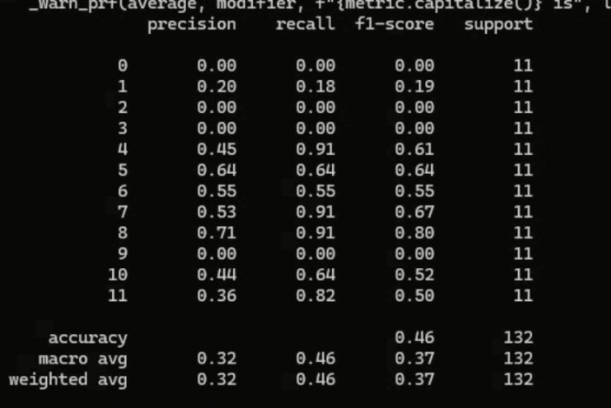
Accuracy 46%, MPNN offers a solid balance between accuracy and f1_score. The model provides good class separation for certain attacks ,aligning well with the t-sne visualization showed strong clustering.

Overall Comparison:
BestModel: GCN has the highest accuracy, indicating a generally balanced performance.
Close Contender: MPNN, with its reasonable accuracy and stronger performance classes.
Underperformance: GAT and GIN, which struggle with classification showing low accuracy and poor F1-scores.
GraphSAGE: Offers a middle ground with decent clustering and classification performance.

- CONCLUSION
In brief ,our Research work has demonstrated the potential of leveraging Graph Neural network (GNNs) to automate and enhance the detection of network intrusions in IoT and traditional network environments. By utilizing flow-level data from the ACI-IoT-2023 and CIC-IDS 2017 datasets, we have built a robust framework capable of accurately identifying and classifying various network attacks. Our approach addresses challenges such as dataset imbalance meaningful graph construction and scalable model training.
Through the integration of domain-specific insights and advanced GNN architectures like GCN, GAT, GraphSAGE, GIN and MPNN, we deliver practical solutions for researchers, industry stakeholders and cybersecurity practitioners. This work not only highlights the efficiency of GNNs in modelling complex relationships within network traffic but also paves the way for scalable ,real time intrusion detection system .As further research and technological advancements emerge, this multidisciplinary effort represents a significant step toward improving network security, mitigating cyber threats, and securing modern digital infrastructures.

- . FUTURE ENHANCEMENT
Adding more attack to predict it and also combine all the process and convert to API or website.

References

1. Zhou, X., Liang, W., Li, W., Yan, K., Shimizu, S., Kevin, I., & Wang, K. (2021). Hierarchical adversarial attacks against graph-neural-network-based IoT network intrusion detection system. IEEE Internet of Things Journal, 9(12), 9310-9319.

2. Bilot, T., El Madhoun, N., Al Agha, K., & Zouaoui, A. (2023). Graph neural networks for intrusion detection: A survey. IEEE Access, 11, 49114-49139.

3. Aborokbah, M. (2024). A novel intrusion detection model for enhancing security in Smart City. IEEE Access.

4. Aly, A., Iqbal, S., Youssef, A., & Mansour, E. (2024). MEGR-APT: A Memory-Efficient APT Hunting System Based on Attack Representation Learning. IEEE Transactions on Information Forensics and Security.

5. Nivedhidha, M., Ramkumar, M. P., & GSR, E. S. (2023, July). CopulaGAN Boosted Random Forest based Network Intrusion Detection System for Hospital Network Infrastructure. In 2023 14th International Conference on Computing Communication and Networking Technologies (ICCCNT) (pp. 1-7). IEEE.

6. Le, H. D., & Park, M. (2024, January). Enhanced GraphSAGE for Multi-Class Intrusion Detection. In 2024 International Conference on Information Networking (ICOIN) (pp. 39-41). IEEE.

7. Kisanga, P., Woungang, I., Traore, I., & Carvalho, G. H. (2023, February). Network anomaly detection using a graph neural network. In 2023 International Conference on Computing, Networking and Communications (ICNC) (pp. 61-65). IEEE.

8. Gorricho-Segura, M., Echeberria-Barrio, X., & Segurola-Gil, L. (2023, June). Edge-based Analysis for Network Intrusion Detection using a GNN Approach. In 2023 JNIC Cybersecurity Conference (JNIC) (pp. 1-7). IEEE.

9. Singh, S. P., Abhay, B., Kumar, A., Agrawal, P., Singh, D., & Ghosh, V. (2024, June). An Efficient Approach Using Graphical Neural Network for Network Intrusion Detection System. In 2024 15th International Conference on Computing Communication and Networking Technologies (ICCCNT) (pp. 1-11). IEEE.

10. El-Dawy, S., Hussien, A., Ammar, M., & El-Dawy, A. (2024, May). Safeguarding Smart Vehicles: GNN-Powered Real-Time IDS for CAN Networks. In 2024 International Conference on Machine Intelligence and Smart Innovation (ICMISI) (pp. 228-231). IEEE.

11. Zhang, L., Wang, Y., Wu, M., Wang, Y., & Zheng, Y. (2023, September). Network Intrusion Detection Based on Graph Neural Network and Ensemble Learning. In 2023 CAA Symposium on Fault Detection, Supervision and Safety for Technical Processes (SAFEPROCESS) (pp. 1-6). IEEE.

12. Santos Escriche, E. (2024). Channel-Centric Spatio-Temporal Graph Networks for Network-based Intrusion Detection.

13. Rbah, Y., Mahfoudi, M., Fattah, M., Balboul, Y., Mazer, S., Elbekkali, M., & Bernoussi, B. (2024, June). Deep Learning for Enhanced IoMT Security: A GNN-BiLSTM Intrusion Detection System. In 2024 International Conference on Circuit, Systems and Communication (ICCSC) (pp. 1-6). IEEE.

14. Meng, Q., Wang, H., Oo, N., Lim, H. W., Schätz, B. J., & Sikdar, B. (2023, October). Graph-Based Attack Path Discovery for Network Security. In 2023 7th Cyber Security in Networking Conference (CSNet) (pp. 178-184). IEEE.

15. Zhang, H., & Cao, T. (2024, December). A Hybrid Approach to Network Intrusion Detection Based On Graph Neural Networks and Transformer Architectures. In 2024 14th International Conference on Information Science and Technology (ICIST) (pp. 574-582). IEEE.

16. Chattopadhyay, A., Bisariya, S., Patel, A., Sunkara, S., & Sutrakar, V. K. (2024, May). Deep learning based graph neural network technique for hardware trojan detection at register transfer level. In 2024 IEEE 4th International Conference on VLSI Systems, Architecture, Technology and Applications (VLSI SATA) (pp. 1-5). IEEE.

17. Lakha, B., Mount, S. L., Serra, E., & Cuzzocrea, A. (2022, December). Anomaly detection in cybersecurity events through graph neural network and transformer based model: A case study with BETH dataset. In 2022 IEEE International Conference on Big Data (Big Data) (pp. 5756-5764). IEEE.

18. Ghanbari, M., & Kinsner, W. (2021, September). Detecting DDoS attacks using an adaptive-wavelet convolutional neural network. In 2021 IEEE Canadian Conference on Electrical and Computer Engineering (CCECE) (pp. 1-7). IEEE.

19. Jing, R., Tian, H., Zhou, G., Zhang, X., Zheng, X., & Zeng, D. D. (2021, July). A GNN-based Few-shot learning model on the Credit Card Fraud detection. In 2021 IEEE 1st International Conference on Digital Twins and Parallel Intelligence (DTPI) (pp. 320-323). IEEE.

20. Khamis, A. K., & Agamy, M. (2023, October). Three-Phase Inverter Dynamics Predictions Using GNN-based Regression Model. In 2023 IEEE Energy Conversion Congress and Exposition (ECCE) (pp. 6289-6294). IEEE.

